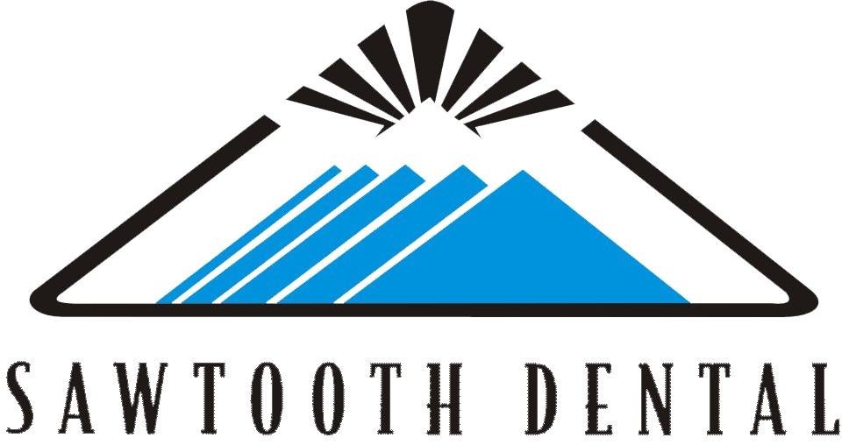

SAWTOOTH DENTAL VIP REWARDS CLUB

What do you get as a member?
- Two exams, two cleanings*(ask about periodontal treatment coverage), fluoride and x-rays as needed, including pano.
- 20% off basic treatment (fillings, extractions, perio treatment* etc.)
- 10% off major treatment (crowns, bridges, dentures, implants etc.)
- Bleach whitening trays-$50 an arch

What does a year membership cost?
- Only $260 a year per adults (14 years and older)
- Only $212 a year per child (13 years and younger)

What will you save?
Usual yearly fees VIP yearly fees
Two exams $80 Two exams
One set of x-rays $89 One set of x-rays
Two Cleanings* $166 Two Cleanings*
TOTALING: $355 TOTALING: $260

PLUS 10-20% OFF ANY TREATMENT NEEDED!

****** Please call today to schedule an appointment 208-733-4515 ******

What’s the Catch?
- Membership must be paid in full before treatment is started or day of treatment
- All membership fees are Non-Refundable
- Membership benefits do not extend to family members or friends

****Subject to change and some conditions may apply****

